**Arduino – Measuring Distance**

**1:CODE**

/* HC-SR04 Ultrasound Sensor Connection with Arduino:

VCC => Arduino +5v

GND => Arduino GND

Echo => Digital Pin 11

Trig => Digital Pin 12

*/

#define echo 11 // Echo Pin

#define trig 12 // Trigger Pin

long travel_time, distance; // Duration used to calculate distance

void setup() {

 Serial.begin (9600);

pinMode(trig, OUTPUT);

pinMode(echo, INPUT);

}

void loop() {

digitalWrite(trig, LOW);

 delayMicroseconds(2);

//Sending a high pulse to trigger the Ultrasound Module

digitalWrite(trig, HIGH);

 delayMicroseconds(10);

digitalWrite(trig, LOW);

 travel_time = pulseIn(echo, HIGH);

//Calculating the distance

 distance = (travel_time*0.034)/2;

// Sending the distance to computer

 Serial.println(distance);

//Delay for next reading.

 delay(30);

}

**2:DESCRIPTION**

This lab was very easy to complete. I already had my breadboard wired up from the last lab, so I removed the LED, Potentiometer, and wires needed to make that circuit work. I used the dupont wire as a way to separate the relatively large sonar module from the breadboard and hooked it up to the breadboard at f8-f11, with f11 being 5v, f10 being trigger, f9 being echo, and f8 being ground. I ran wires from 5v and ground to their respective pinouts on the power rail, and then wired trigger and echo up to pins 12 and 11 on the Arduino. I created a new sketch, verified it, and then uploaded it. The distance measurement worked correctly the first time.

**3:Pictures/Video**

[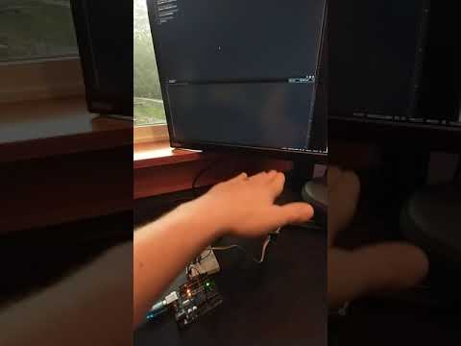](https://www.youtube.com/embed/yEPBPoMGM3g?feature=oembed)